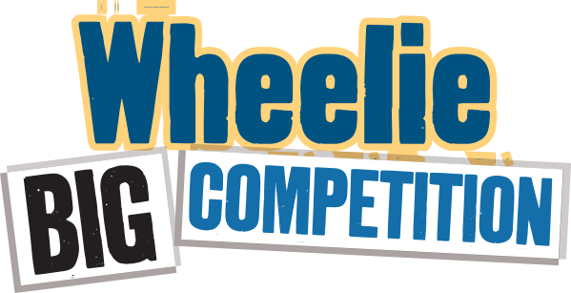

**Entry 2024-25**

Submit a brief description below of the actions you took at school and at home to improve recycling and reduce waste. No more than 250 words in total – don’t forget to mention food waste actions! Include any waste audit information you have. You may include up to 3 photos with your written answer.

**School name:**

At school (200-250 words):

At home (50 words optional):

Photos – Copy Below:

Submit your entry by **7th February 2025** to your field officer and [eco-schools@keepnorthernirelandbeautiful.org](mailto:eco-schools@keepnorthernirelandbeautiful.org)

Schools will be awarded their prizes at the Green Flag Awards ceremonies in June.

Prizes are - **First Place - £500**

**Second Place - £300**

**Third Place- £200**